Name ___________________
ACTIVITY 7-6
THE BREAK-IN

Directions: Complete the steps for the activity listed in your textbook. Record your results in the table and answer the questions below.

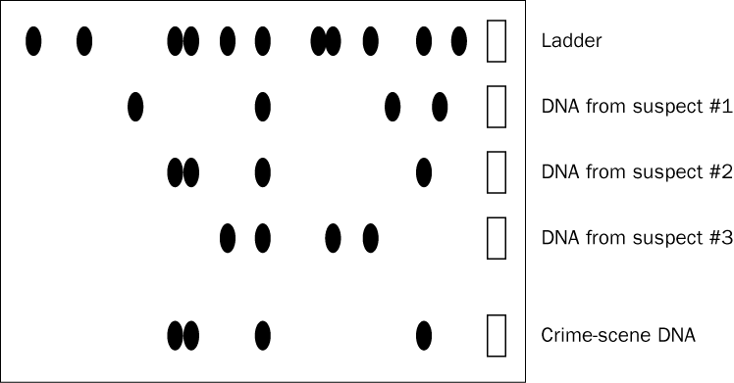

Questions:

- Does the crime-scene DNA match the DNA from any of the suspects? If so, which one(s)?

- Is there more than one DNA match? Explain.

- Is this DNA profile sufficient to convict a suspect? Explain.

